# Foundations of Robotics – Project 1 Report

Chinmay Prashanth

cp3873

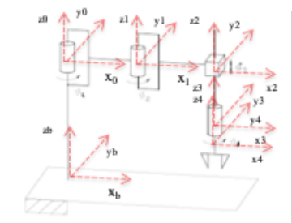

Part 1:-

Methodology:

Here, in this part we’ve used Matlab/Simulink algorithm to obtain Kinematic Inversion of Jacobian Inverse and Transpose.

Below is the Jacobian 4X4 matrix, used to track 4 DOF’s in operational space of an End Effector. The differential equation of Forward Euler Integration is used

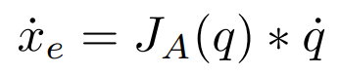Forward Euler Integration

Here we’ve obtained the analytical jacobian by differentiating the position and orientation of end effector. Joint velocity vector are used to compute joint components at each time instant for desired end effector velocity.

The jacobian_inverse and jacobian_transpose function have used the below 4 rank jacobian matrix. In Jacobian Inverse, the inverse of Jacobian matrix has been multiplied by Kin which is the desired velocity at the end effector. In Jacobian transpose, the transpose of Jacobian has been multiplied by the Kin. Both functions have been defined in their respective SimuLink Models.

The Position and Orientation expression for the end effector is defined in the direct_kin file. The translation part of the homogeneous transformation from base to end effector is considered as 3X1 form then the angles are included in new matrix to obtain Position and Orientation.

Finally, after defining all the function in their respective Simulink file, all the visualization and loading the trajectory from the predefined file is happening in init.m with the help of Kinematic_traj and visualize_results files.

Result:

Simulink Model:

Jacobian Inverse

Jacobian Transpose

Here, the Simulink Model for both Jacobian Inverse and Transpose have been created in clik_inverse and clik_transpose Simulink files. All the input variables are being imported from the workspace by using ‘From Workspace’ blocks and the all the output variables are exported back to workspace by ‘To Workspace’ blocks which are being visualized.

Plots:

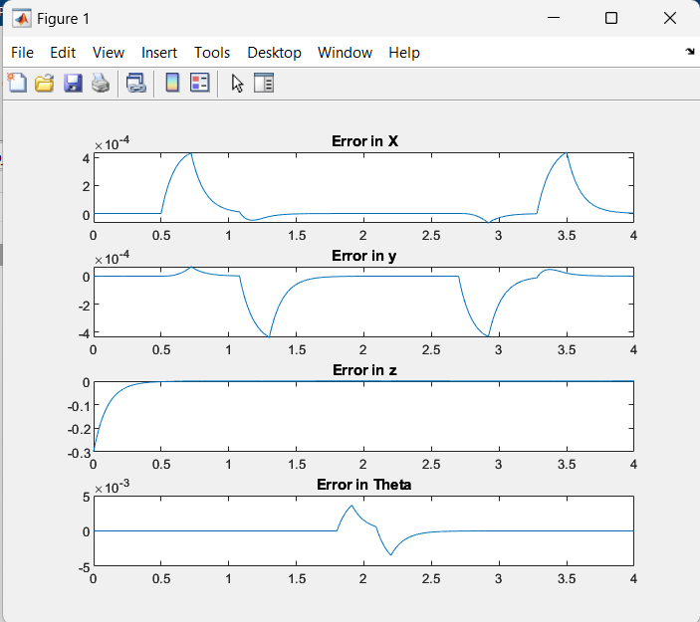 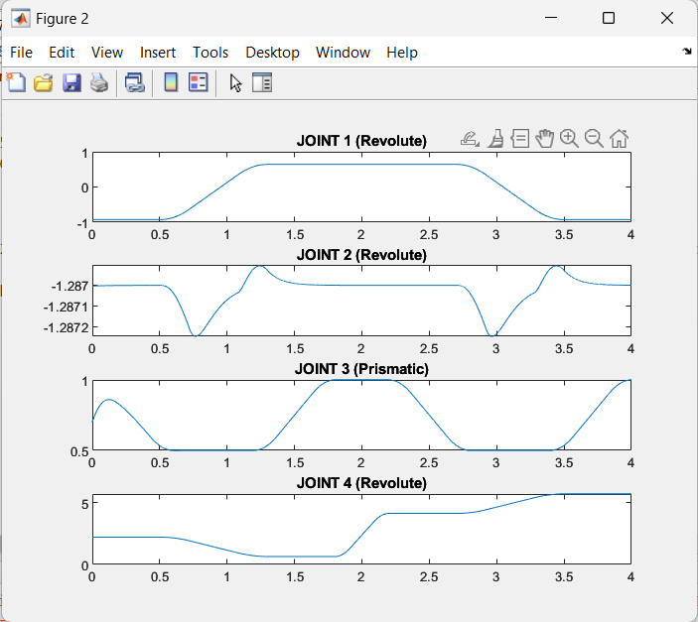

Jacobian Inverse

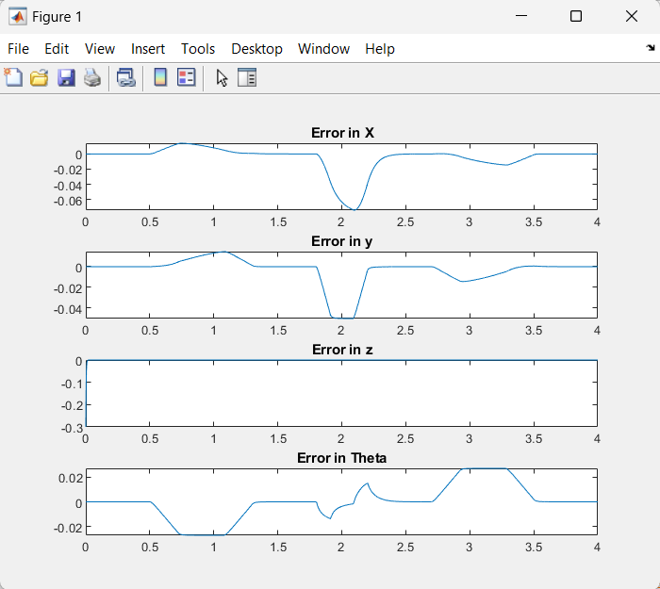

Jacobian Transpose

Part 2:

Methodology:

The redundancy of a SCARA manipulator is used by relaxing the revolute joints (Z axis) in the workspace. The sum of separate joint angular velocity will be relaxed. Due to the relaxation, we obtain a non-square jacobian matrix (similar to the previous jacobian matrix but with last row removed).

The above non square matrix is representing a system, with 4 variables for 3 equations, which means that will have infinite solutions for velocity. Velocity equation is considered as,

Result:

Simulink model:

Jacobian_phi_relax

Here the jacobian_phi_relax is implemented into the model in the interpreted Matlab function and Position variables are defined in the direct_kin.

Plots:

